**Notice board brief**

**Game research:**

The Witcher 3: Wild Hunt

The Witcher 3: Wild Hunter (or simply “The Witcher”) has notice boards available in different towns in the game. By going up to these noticeboards the player can read the papers on this board, these papers can initiate side quests.

Pokémon Mystery Dungeon

Pokémon mystery dungeon has a bulletin board that pushes the player back towards the core game loop in a diegetic way.

The game itself is about exploring dungeons. On the bulletin board, rescue missions or job postings will be listed, for example:

* “Help needed! Rescue a lost Pikachu deep in the caves of {cave_name}”
* “Item wanted! Paying 40 gold to anybody who can retrieve the treasure from {cave_name}”

These are listings from “NPCs” that exist in the diegetic world. By going up to this board, the player can get challenges and tasks to do, but they are a part of the world. This creates more immersion than simply having a challenge to “Unlock the treasure for 40 gold”.

To access this notice board, players have to go to where the board exists within the game world, by going up to the board itself they can read it. This furthers the diegetic aspect.

Stardew valley

Star dew valley introduces quests to the player via a bulletin board. Like Pokémon mystery dungeon, it does this in a diegetic way.

Instead of simply having a quest of “Retrieve the lost quartz”, job listings are posted by NPCs. Below is an image of an example quest within Stardew valley:

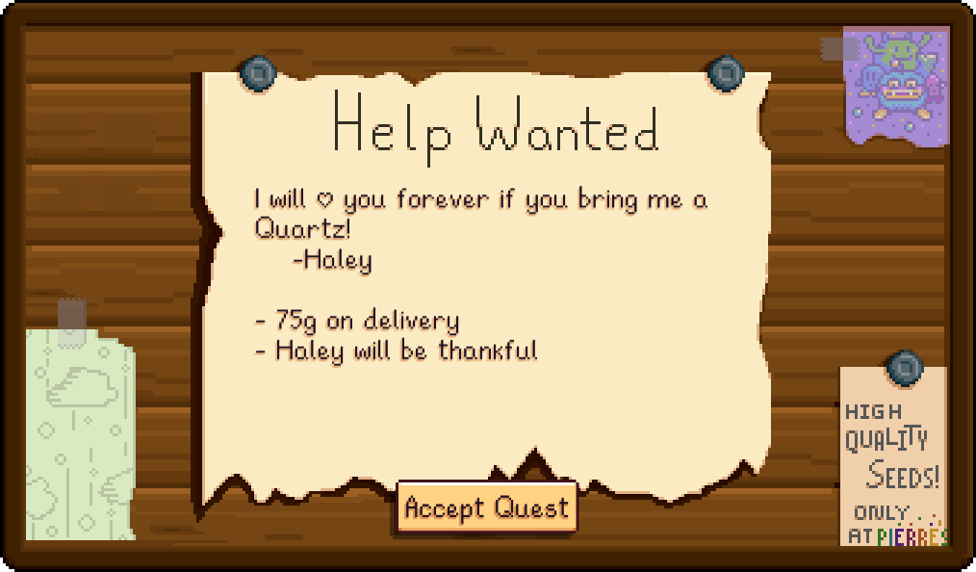

Our Game:

**How to access:**

A notice board will be accessible to players, it can be either diegetic or accessed via a menu button on the screen.

**Why and What does it display:**

When the player opens the app, the player can check the noticeboard to find out about the prices of potions, any special offers currently happening and any quests being offered.

This allows players to make decisions of what they want to do next; what potions do they want to make, do they need to adjust any factories, etc.

**Potion prices:**

Potions do not always sell for the same price, a potion may be very profitable one day, however the next day its price may fall and another potion may sell for more.

Potion prices will change on a daily basis, once per day.

**Special offers:**

Special offers are short-time events (less than one-two hour(s)) that occur frequently throughout the day. This will be a potion selling for an increased price for a short period of time. By checking the app regularly, players can check what special offers are available and go into their factories to produce this specific potion.

**Quests?:**

We could offer quests to the players, an example of a quest may be a challenge to unlock or perform a task in the game such as “Create an ‘x’ potion in less than 15 cycles”. We can reward the player with experience and currency.

**Example noticeboard:**

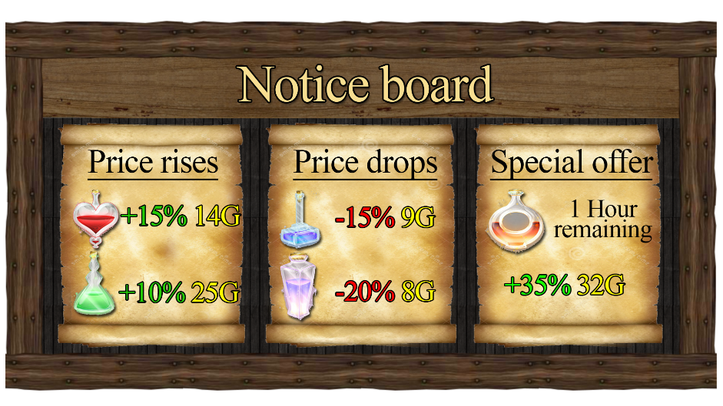

Referenced games:

The Witcher 3: Wild Hunt: <http://thewitcher.com/en/witcher3>

Pokemon Mystery Dungeon: <http://www.pokemonmysterydungeon.com/supermysterydungeon/>

Stardew valley: <http://store.steampowered.com/app/413150/Stardew_Valley/>

Image references

*St Mary’s Church, Moorlinch, Noticeboard* [Image] Available online: <https://moorlinch.wordpress.com/photo-galleries/around-moorlinch/>

*East Chelborough Victorian Postbox and Noticeboard* [Image] Available online: <https://commons.wikimedia.org/wiki/File:East_Chelborough_Victorian_Postbox_and_Noticeboard_-_geograph.org.uk_-_405884.jpg>

*Help Wanted* [Image] Available Online: <https://stardewvalleywiki.com/File:Help_Wanted.png>